Balance Detectors
David Grayson
A Participant Report regarding the Research Experience in Physics and Astronomy for Undergraduates program at the University of Rochester
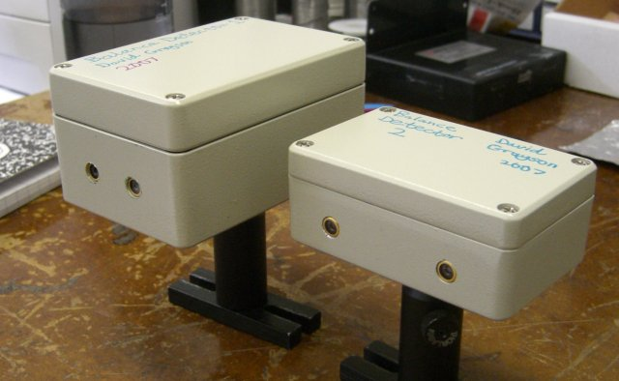
Figure 1: Two of the five balance detectors I built this summer. Left: BD1. Right: BD2.

This summer, I had the pleasure of doing research in John Howell’s quantum optics laboratory. My objective for the summer was to build five working balance detectors. A balance detector is an electronic device that measures the difference in the intensity of two laser beams. I figured out how to build a balance detector, built five of them, and I tested them to see how they performed.
The laboratory already possessed one balance detector, housed inside an aluminum box, consisting of two photodiodes connected to a simple electronic circuit. This balance detector was built by Michael Pack, a former graduate student of the group. By examining this balance detector, I determined its circuit diagram. Using equipment I found in the laboratory, I built a prototype balance detector on a breadboard and mounted it on an optics table. The balance detector did not work at first. Using trial-and-error, I found the problem in my circuit diagram and fixed it. Then I tested the prototype balance detector’s sensitivity using a 780nm fiber laser source and some optical components. My prototype balance detector’s sensitivity was shown to be close to the sensitivity of the old balance detector (.25 V/μW).
So then I built five balance detectors using what I had learned. This involved thoughtful design work, shopping online for the right parts, ordering them, drilling holes in aluminum boxes, sawing the rim off of a breadboard, soldering, gluing, and solving various unexpected problems. Figure 1 shows the balance detectors I built.
I performed two major tests on the new balance detectors to ensure their quality. For the first test, I measured each detector’s sensitivity, and found that the sensitivities were close to that of the prototype. This was expected because the new balance detectors used the same circuit diagram as the prototype.
For the second test, I measured the new balance detectors’ response when the intensities of the two laser beams are very close to equality. I made those intensities very close to equality by rotating a quarter wave plate to change the polarization of the laser before it hits a polarizing beam splitter. The tests showed that the new balance detectors can be trusted to detect differences in intensity as small as 2µW as long as average intensity is less than 120µW.
I completed my objective this summer. As a result of my work, the Howell group now has two more balance detectors. Additionally, I documented all of my findings, so they have the knowledge needed to build more balance detectors.

This material is based upon work supported in part by the National Science Foundation under Grant No. PHY-0552695.

