The Balance Detector: A Useful Tool for Quantum Optics Experiments

David Grayson, University of Illinois Physics Department.
Based on work done at the University of Rochester
Department of Physics and Astronomy.

A balance detector is a device that measures the intensity difference in two laser beams (of the same color) by producing an output voltage that is proportional to the intensity difference of the two laser beams. Balance detectors are useful in many optics experiments, including a novel new experiment to test general relativity on a table top. Five balance detectors were built. The response near zero and the sensitivity of these balance detectors were tested.

Introduction

A novel new experiment is underway in the laboratory of Professor John Howell at the University of Rochester. This experiment aims to test general relativity—Einstein’s 90-year old theory of gravity. Most previous experiments to test general relativity require the use of large distances. Previous experiments have used high flying planes, satellites, and light from distant stars.
However, this new experiment in the Howell laboratory is novel because it proposes to test general relativity on a table top. When light travels towards or away from the Earth (up or down), its frequency changes due to gravity. If the frequency of the light is thus changing while it propagates in a slow light medium, then the light picks up a phase change that depends on whether the light is traveling upwards or downwards [1]. The aim of the novel new experiment is to accurately measure this phase change in order to test general relativity. This is done by shining a laser in to a sagnac interferometer with a slow light medium in one arm, and using a balance detector to compare the intensity of the output beam of the interferometer to a reference beam.
A balance detector is a device that precisely measures a small difference in the intensity of two laser beams. A balance detector absorbs two laser beams and produces a voltage which is proportional to the difference in their intensities (up to a certain cutoff voltage). Balance detectors have been built before, but no previous literature on how to build a simple balance detector was found.
The work presented here is about building five simple balance detectors and testing them.
Prior to this work, John Howell’s group already possessed one simple balance detector, consisting of two photodiodes connected to an analog electronic circuit, housed inside an aluminum box. This balance detector was built by Michael Pack, a former graduate student of the group. The circuit diagram of this balance detector was determined through examination. The basic idea of the circuit is that the two photodiodes, connected to opposite voltages, are competing to affect the voltage of the common conductor they are connected to. Shining a laser in to a photodiode increases the connection between the two sides, increasing its ability to affect the voltage of the common conductor. Using equipment found in the laboratory, a prototype balance detector was built and mounted on the optics table. Tests revealed that the prototype balance detector’s sensitivity was comparable to Michael Pack’s balance detector. Thus, five more balance detectors were built for the laboratory.
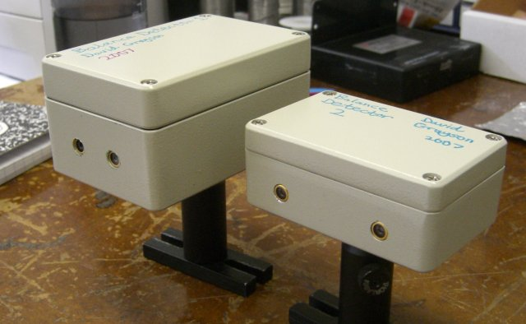
Figure 1: The first two balance detectors built
this summer. Left: Balance Detector 1.
Right: Balance Detector 2.

The new balance detectors were tested to ensure their quality. The most important test performed was a measurement of each balance detector’s response when the intensities of the two laser beams are very close to equality. This test determined an upper limit on how small an imbalance the balance detectors can detect. Equipment used to perform this test included a 780-nm fiber laser source, optical components, and a power meter (to measure the intensity of a laser beam directly).
As a result of this work, the Howell Group now has five more balance detectors. Two of those balance detectors are being used in the novel new experiment to test general relativity.

Procedures

Testing General Relativity on the Table Top

A rubidium vapor slow-light medium has been developed that slows down light. When light propagates upward through the medium, there is a red shift due to gravitation. The changing frequency of the light causes a phase change. Phase changes can be accurately measured by interferometers. That is the basis of the novel new experiment to test general relativity.
More specifically, two laser beams are coupled in to an optical fiber. The beams have different wavelengths and perpendicular polarizations. The beams emerge from the optical fiber and are sent through a Sagnac interferometer. The beams are each split by a 50/50 beam splitter. One piece enters a Sagnac interferometer with a rubidium vapor slow-light medium, designed to slow down the different beams to different speeds. The intensity difference between the two pieces from one laser is measured with a balance detector in order to detect fluctuations in the system. The voltage output of the balance detector is used to automatically move a mirror of the Sagnac interferometer in order to cancel out these fluctuations. The intensity difference between the two beams from the other laser is measured with a second balance detector.

Building a Balance Detector

To build a balance detector, an appropriate circuit (see Figure 1) must be created and mounted in a sturdy box (see Figure 2).

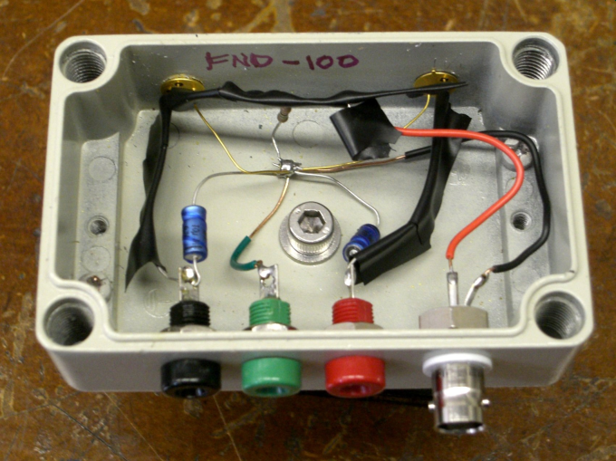
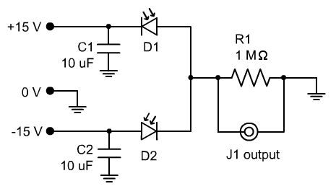
Figure 2: The balance detector circuit
mounted in a sturdy aluminum box.
Figure 1: Balance detector circuit diagram.
D1 and D2 are photodiodes. The output voltage at J1 is proportional to the difference in intensity of the lasers shining in to D1 and D2 up to ±15V.

The most important component of the balance detector is the photodiodes. Both photodiodes in a balance detector should be the same model. Photodiodes with a sensitivity of about 0.55 A/W for 780nm light were used.
The resistance R1 depends on the photodiodes. Using a resistance that is too low results in low detector sensitivity. Using a resistance that is too high results in a balance detector whose voltage always decays slowly to zero. Therefore, it is wise to build a prototype balance detector and try various resistances to figure out which one is the best.

Building a Balance Detector Testing Apparatus

In order to test the balance detector, it is necessary to have a testing apparatus that can train laser beams on the balance detector’s photodiodes, adjust the intensity of the laser beams, measure the intensity of the laser beams, and measure the output voltage of the balance detector. Such an apparatus was created on an optical table, as described in Figure 3.

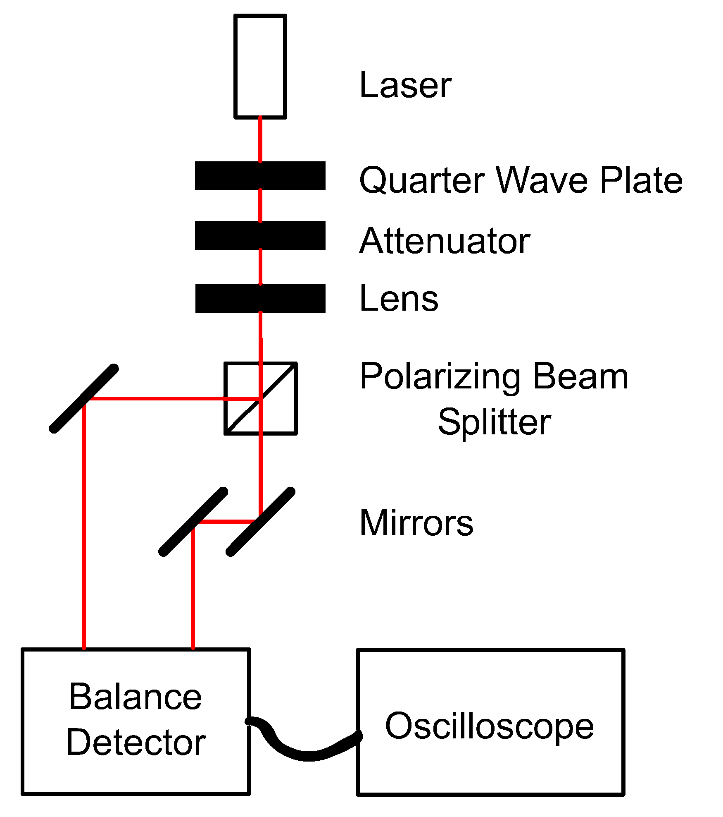
Figure 3: The balance detector
testing apparatus. Not shown: movable power meter.
The apparatus shown in Figure 3 meets all of the requirements for a balance detector testing apparatus. The lens and the adjustable mirrors are used to train the laser beams on to the balance detector’s photodiodes. The ratio of the laser beam intensities can be adjusted by rotating the quarter wave plate. The intensity of the beams can be directly measured using a power meter. The output voltage of the balance detector can be measured with the oscilloscope.
It is important that the laser beam incident on the polarizing beam splitter be perpendicular to its surface. If not, it may not be possible to set the laser beam intensities equal to each other.

Measuring a Balance Detector’s Response near Zero

In this experiment, balance detectors are used to detect small imbalances in laser beams with nearly equal intensities. Thus it is important to test the balance detector’s behavior in this regime. This is called the “Response near Zero” because the output voltage of the balance detector should be zero when the two beams are equal.
The procedure for testing a balance detector’s response near zero, using the apparatus in Figure 3, is as follows:
- Train the laser beams on the photodiodes of the balance detector.
- Adjust the power of your laser and the transmission of the attenuator to achieve the desired average intensity of the laser beams.
- While monitoring the balance detector’s output voltage on the oscilloscope, rotate the quarter wave plate to set the time-averaged output voltage to zero.
- Measure and record the power of the two laser beams with the power meter. It is necessary to put the power meter directly in front of either photodiode in order to measure the power of the laser beam accurately, since mirrors do not reflect perfectly.
- Repeat steps 2-4 to obtain more data points.
The data obtained from this procedure (available in the Response Near Zero Results section) was used to determine an upper limit on how small an imbalance the balance detectors can detect. This upper limit was shown to depend on the average intensity of the laser beams.

Measuring a Balance Detector’s Sensitivity

In order to interpret the meaning of a non-zero reading on a balance detector, the sensitivity of that balance detector must be known. The sensitivity is the proportionality constant that relates the intensity difference of the laser beams to the output voltage. The sensitivity has units of V/µW. The procedure for testing a balance detector’s sensitivity, using the apparatus in Figure 3, is as follows:
- Train the laser beams on the photodiodes of the balance detectors.
- Adjust the power of the laser and the transmission of the attenuator to achieve the desired average intensity of the laser beams. Make it small enough to minimize output voltage noise, but large enough so that a wide range of voltages can be achieved by rotating the quarter wave plate.
- Rotate the quarter wave plate by the desired amount. Care must be taken not to saturate the balance detector by giving it such a large imbalance that the output voltage is ±15V.
- Record the time-averaged output voltage using the oscilloscope.
- Record the intensities of the two laser beams using the power meter.
- Repeat steps 3-5 to obtain more data points.
The data obtained from this procedure was used to determine if the balance detector’s output voltage is proportional to the laser beam intensity difference. If the two quantities are proportional, then the measured proportionality constant is the sensitivity of the balance detector.

Results

Sensitivity Results

Sensitivity tests were carried out on balance detector 1 and balance detector 2 The results show that both detectors behave linearly and are approximately as sensitive as the old balance detector, which has a sensitivity of 0.25 V/µW (see Figure 1).

Figure 1: The data from the sensitivity tests of balance detector 1 and balance detector 2. The slope of the linear fits indicate that balance detector 1 has a sensitivity of 0.27 V/µW and balance detector 2 has a sensitivity of 0.24 V/µW.

Response Near Zero Results

The response near zero of balance detectors 1 through 5 were measured, and the results are shown in Figure 2. The error bars on the figure represent the in-quadrature-combined range of the fluctuations of the two readings on the power meter, as judged by the human making the measurements.
While the results for the different balance detectors vary, the typical balance detector can detect laser beam intensity differences as small as 2 μW when the average intensity of the laser beams is less than 120 μW.
All balance detectors showed a better response near zero for smaller average intensities. When weak lasers are shone onto the balance detectors, the detectors can measure very small differences in intensity. When brighter lasers are shone onto the balance detectors, they cannot measure intensity differences as sensitively. One possible explanation for this effect is that the photodiodes have a non-linear response that becomes manifest for the more intense laser beams, and this non-linear response is not the same among all the photodiodes.

Figure 2: The data from the response near zero tests. Each data point represents a time when the time-averaged voltage reading on the balance detector was zero. Datapoints with a small intensity difference indicate that the balance detector has a good response near zero. This high-quality response near zero decreases as the average intensity increases.

Conclusion

The Howell Laboratory now has five new balance detectors. Two are currently being used in the novel new experiment to test general relativity.

References

[1] S. Manly and E. Page, Phys. Rev. D 63, 062003 (2001)

